**SPRINT – 4**

| **TITLE** | **Smart Farmer-IOT Enabled Smart Farming**  **Application** |
| --- | --- |
| **DATE** | 17 November 2022 |
| **TEAM ID** | PNT2022TMID15210 |

**Receiving commands from IBM cloud using Python program** 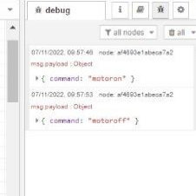

**WEB UI:** 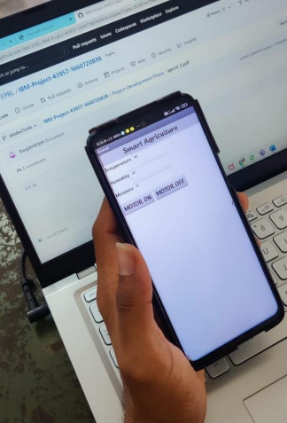

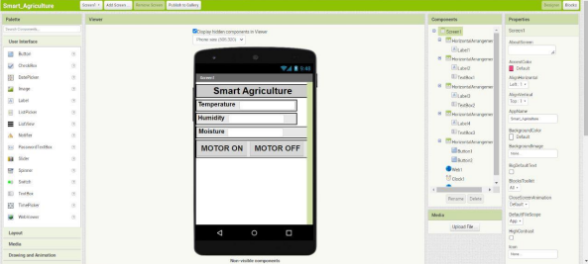

HUMIDITY

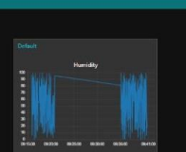

TEMPERTAURE

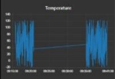

SOIL MOISTURE

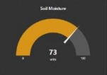

Advantages & Disadvantages Advantages:

• Farms can be monitored and controlled remotely.

• Increase in convenience to farmers.

• Less labor cost.

• Better standards of living.

Disadvantages:

• Lack of internet/connectivity issues.

• Added cost of internet and internet gateway infrastructure.

• Farmers wanted to adapt the use of Mobile App.

Conclusion

Thus the objective of the project to implement an IOT system in order to help farmers to control and monitor their farms has been implemented successfully.